Press Release: Printess is Transforming Product Personalization with Innovative AI Technology
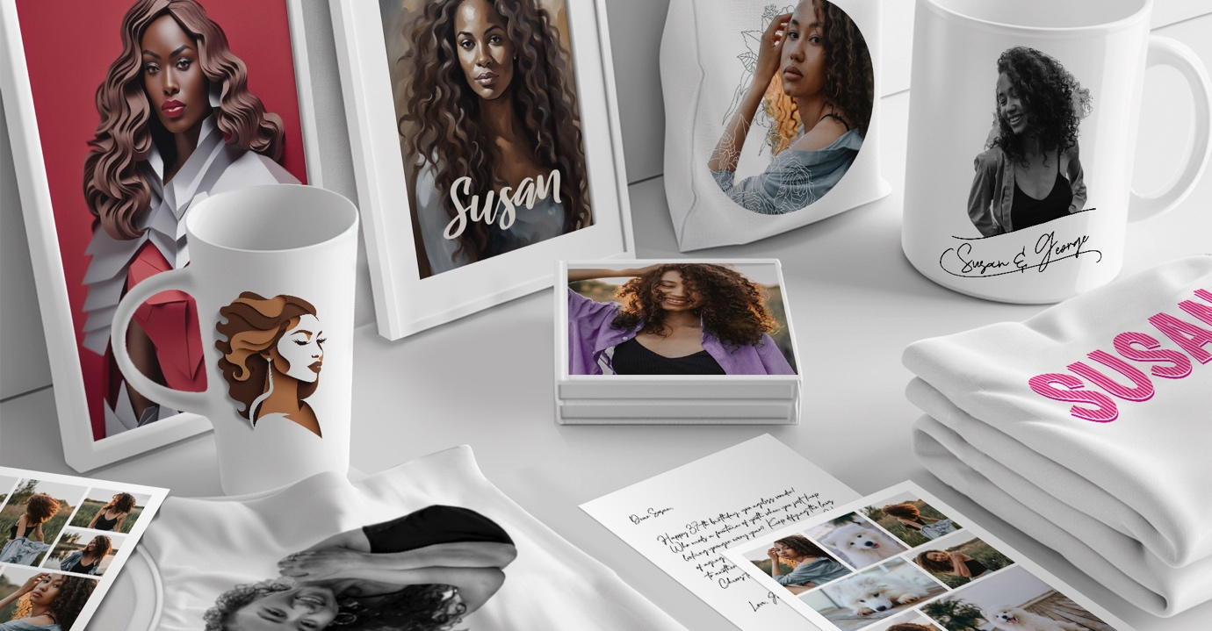
27 June 2024, Berlin, Germany: Printess combines two decades of industry expertise with innovative thinking and state-of-the-art technology to elevate personalization businesses. The platform empowers teams to effortlessly design and sell mass customized products across all devices, eliminating the need for coding. This scalable, cloud-based white-label solution integrates seamlessly with any e-commerce platform, offering a vast array of templates, exceptional design capabilities, and flawless production quality. Printess have yet again pushed the limits of personalization possibilities with their innovative AI technology.

“Artificial Intelligence has become the norm in the consumer space and is almost an expectation from users when making purchases online. By integrating specific AI tools into our personalization editor, we have given both B2B and B2C businesses the benefits of providing AI tools to customers without the price tag.” Says Christoph Schacht, Co-Founder of Printess.
Printess have combined the most popular AI tools to provide the best experience to users regardless of their needs. The toolset includes, but is not limited to:

Generative AI: This feature allows users to bring their imagination to life with a simple prompt in just a few seconds. Whether it's a unique design concept or a bespoke product image, the generative AI creates stunning visuals that perfectly match the user’s vision.

AI Text Assistant: The Printess AI text assistant is an advanced tool that crafts the perfect message for any occasion, ensuring any greeting card resonates with warmth and personal touch, regardless of the occasion.

Image Background Removal: Say goodbye to unwanted photo bombers with Printess’s precise background removal tool, making images clean and professional in seconds with no hassle.

Face Swapping Features: Add a fun twist to your products with our face-swapping feature. Transform into iconic figures like Aquaman or Marilyn Monroe for memorable birthday cards or custom prints.

“Printess is designed to grow with your business, fitting effortlessly into your existing e-commerce setup. The platform offers intuitive, easy-to-use features that empower any team to deliver personalized products that stand out in the market. With Printess, you can confidently scale your operations, knowing you have the best tools at your disposal.” Comments Harshad Ghude, Global Business Development and Customer Success Manager at Printess.

Businesses worldwide are already experiencing the benefits of Printess's top-notch customization tools. Their commitment to innovation ensures that their customers stay ahead in the competitive personalization market. If you would like to see Printess in action, you can visit https://www.printess.com/index.html or contact sales@printess.com to arrange a personalized demonstration.

About Printess

Printess combines 20 years of experience with the latest advancements in technology to provide a comprehensive solution for product personalization. Their mission is to enable businesses of all sizes to create, sell, and thrive in the world of customized products, without the hassle of complex coding or upfront investments.

Contact Information

For more information about Printess and their AI-powered personalization tools, please visit https://www.printess.com/index.html or contact their team at sales@printess.com

